ENGLISH 6 – CLASS 6A1, 6A2, 6A3
REVISION (UNIT 7)
I. Choose the word that has the underlined part pronounced differently from the others
1. A. thirty B. theme C. both D. them
2. A. brother B. weather C. through D. than
3. A. schedule B. comedy C. red D. when
4. A. channel B. game C. national D. relax
5. A. show B. programme C. sport D. most
II. Choose the word whose main stress is placed differently from the others
1. A. cartoon B. viewer C. boring D. local
2. A. channel B. studio C. schedule D. director
3. A. national B. forecast C. entertain D. comedy
4. A. clumsy B. remote C. volume D. funny
5. A. programme B. produce C. announce D. event
III. Choose the correct answer (A, B, C or D)
1. __________ hours a day do you learn English ? – Two hours.
A. How many B. How much C. How often D. How long
2. ___________is your favourite TV programme ? – Cartoon.
A. Who B. What C. When D. Where
3. ___________do children like cartoons ? – Because cartoons are colourful and funny.
A. What B. When C. Where D. Why
4. __________ is your school ? – My school is in Tuong Binh Hiep village.
A. Who B. What C. When D. Where
5. __________ time do you spend watching TV ? – One hour a day
A. How many B. How much C. How far D. How old
6. ____________is your English teacher ? – Miss Yen.
A. Who B. What C. When D. Where
7. __________is it from your house to your school ? – About 2 kilometres
A. How often B. How far C. How long D. How
8. ________do you usually do your homework ? – In the evening.
A. When B. Where C. Why D. What
9. ________ does the film start ? – At 7 p.m
A. What B. What time C. How many D. How much
10. _______ is your mother doing now ? – She is cooking dinner.
A. Who B. What C. When D. Where
11. ________ can he go there ? – By bicycle.
A. How B. How old C. How often D. How long
12. ________ does this programme last ? – About 1 hour.
A. How many B. How much C. How long D. How often
13. ________ do you go to the zoo ? – Once a year.
A. How many B. How much C. How often D. How
14. ________ do you prefer, the TV or the radio ?
A. What B. Which C. When D. Where
15. ______ is the trip ? – It’s great.
A. How B. What C. Who D. When
16. _________ apples are there in the fridge ? – Ten apples.
A. How B. How many C. How much D. How long
17. _________does it cost ? – 10 dollars.
A. How much B. How many C. How far D. How long
18. _________ water is in the bucket ? – About 1 litre.
A. How often B. How many C. How much D. What
19. I like watching TV _____ listening to music.
A. and B. but C. because D. so
20. I want to buy a new house, ____ I don’t have enough money.
A. and B. so C. but D. because
21. He always studies hard, ____ he gets good marks.
A. so B. although C. because D. but
22. ______ the football match is late, we will wait to watch it
A. Although B. Because C. But D. And
23. Lan has to go to a doctor _______ she is sick.
A. so B. and C. but D. because
24. They are listening to music, ______ they can’t hear me.
A. and B. because C. so D. but
25. Both Nam ____ Mai love learning English.
A. but B. and C. although D. so
26. ______the weather is bad, we can’t travel.
A. But B. So C. Because D. Although
27. Jill Newman is a (n) __________on News at ten.
A. MC B. newsreader C. interviewer D. teacher
28. Where is the _________ ? I’d like to change the channel.
A. remote control B. volume button C. TV programme D. schedule
29. I love_______. Tom and Jerry are my favourite characters.
A. romances B. comedies C. documentaries D. cartoons
30. Why are you laughing ?- I’m watching a ______. It’s really funny!
A. documentary B. news C. comedy D.drama
IV. Rewrite sentences with “but, and, so, because, although”.

1. I don’t watch news. It is boring. (because)
………………………………………………………………………………………
2. She is seeing a movie at cinema. The film is terrifying. (but)
………………………………………………………………………………………
3. The programme is boring. The MC is bored. (and)
………………………………………………………………………………………
4. I have a lot of homework tonight. I can’t watch Eight Feet Below. (so)
…………………………………………………………………………………………
5. BBC The Coast is a famous TV series. I have never watched it. (although)
………………………………………………………………………………………
V. Make questions for the underlined part

1. There are 40 students in my classroom.
…………………………………………………………………
2. My brother is studying in his bedroom.
………………………………………………………………..
3. My family usually goes to Da Lat on summer vacation.
……………………………………………………………….
4. Her children often go to the club by bike.
..................................................................................................
5. My favorite singer is David Archuleta.
…………………………………………………………………..
VI. Read the passage carefully. Then do the tasks.

Steve, 13
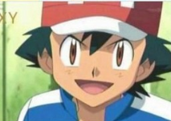
I love TV. The first thing I do when I wake up is to switch it on. My favourite channel is Cartoon Network. I watch TV three or four hours a day. My parents think it is too much and they are always telling me to study, read a little or do a sport. But TV is my favourite hobby. I’m addicted to my favourite programme.

NEWS
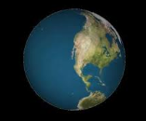
I know most teens don’t like watching the news, but I do. I like to know what is happening around our world. I also enjoy documentaries, especially about wildlife. I’m very curious about the way animals live and and how to preserve their habitats. I also enjoy watching live shows and films, mostly comedies and thrillers. I watch TV two or three hours a day.


I like TV as everybody else, but now that I’m older I am more selective about the programmes I watch. I used to watch cartoons all the time. Now I like watching the news and some game shows like “ Who wants to be a millionaire?”, so I don’t really spend too much time in front of the box, an hour or two a day…Some programmes are educationaland help us to use our imagination, but many are full of violence.

A. Decide whether the following setences are True (T) or False (F)

1. Steve is obsessed with TV.
2. Kate doesn’t like watching the news.
3. Rachel’s favourite programmes are still cartoons.
4. Kate likes watching things that make her laugh.
5. Rachel is the teenager who watches the least TV of the three.
6. Steve’s parents don’t mind that he watches so muchTV.

B. Answer the questions.

1. Which TV programme does Steve like watching ?
………………………………………………………….
2. Why does Kate like watching documentaries on wildlife ?
…………………………………………………………………..
3. How much time does Rachel spend watching TV ?
……………………………………………………………
4. According to Rachel, what are the benefits of TV ?
……………………………………………………………..

REVIEW UNIT 7: TELEVISION
I. Odd one out
1. | A. newsreader | B. film producer | C. comedian | D. programme
2. | A. popular | B. exciting | C. educational | D. reporter
3. | A. world news | B. cartoon | C. documentary | D. studio
4. | A. international | B. boring | C. national | D. local
II. Choose the word whose underlined part is pronounced differently from that of the others
5. | A. channel | B. relax | C. national | D. game
6. | A. programme | B. show | C. sport | D. most
7. | A. schedule | B. when | C. red | D. comedy
8. | A. weather | B. then | C. through | D. brother
9. | A. both | B. thirty | C. theme | D. them
III. Choose the best answer to fill in the blank.
10. | Children can participate in a TV ________ for a game show or a quiz show.
 | A. channel | B. studio | C. competition | D. cartoon
11. | The football match is on at 2 am ________ I can’t watch it.
 | A. so | B. although | C. when | D. but
12. | Many people with different skills work hard ________ quality programmes for television.
 | A. to produce | B. to producing | C. produce | D. producing
13. | Millions of children around the world enjoy the cartoon because it can both ________ and ________ a young audience.
 | A. entertainment - educate |  | B. entertain - education
 | C. entertainment - education |  | D. entertain - educate
14. | If you want to know what the weather is like tomorrow, watch the ________.
 | A. quiz show | B. weather forecast | C. music show | D. game show
15. | My father likes watching sports ________ on VTV 3.
 | A. matches | B. channels | C. events | D. athletes
16. | “________ is that TV programme directed by?” – “By a famous Vietnamese director”.
 | A. What | B. where | C. who | D. when
17. | ________ the newsreader on BBC One reads very fast, my brother can hear everything in the news.
 | A. but | B. But | C. when | D. Although
18. | That TV programme is not only interesting ________ it also teaches children many things about family and friendship.
 | A. how | B. when | C. where | D. what
IV. There is one mistake in each of the following sentences. Find and correct it.
19. | What do you compare the time you spend watching TV to the time you on other activities?  A B C D
20. | Henry wants to go overseas and he does not have enough money.  A B C D
21. | Nam didn't win the race because of he ran too slowly.  A B C D
22. | Where performance in the concert was the most interesting?  A B C D
23. | Although the football game was over, but the fans stayed in their seats cheering.  A B C D
V. Choose true, false or no information.
Television is an important invention of the 20th century. It has been so popular that we can’t imagine what life would be like if there were no television. Television is a major means of communication and entertainment. It brings pictures and sound from around the world into millions of homes. Through television, viewers can see and learn about people, places and things in distant lands. Television widens our knowledge by introducing new ideas which may lead us to new hobbies and recreations. In addition to the news, television provides us with a variety of programs that can satisfy every taste. Most people now seem to like spending their evenings watching television than to go out.
24. | Television is an important means of communication.
 | A. True | B. False
25. | Television provides us with a variety of programs.
 | A. True | B. False
26. | Most people don’t like watching TV in the evening.
 | A. False | B. True
27. | Television can’t satisfy all our tastes.
 | A. False | B. True
28. | People can learn many things through TV.
 | A. True | B. False
VI. Choose true, false or no information.
Information about what happens in the world comes to us in many ways. Television and radio are two important ways of the news. They get the news out faster than the newspapers and magazines, and they don’t have to be read. Television and radio stations broadcast the news several times each day. In America, there are the news programmes every hour. People can choose the favourite TV programmes, such as sports, films, fashion, news, etc. People who cannot read get the news from television or radio easily.
29. | There are only two ways of getting the news.
 | A. False | B. True
30. | Television and radio get the news faster than other ways.
 | A. True | B. False
31. | Television stations broadcast the news several times each day.
 | A. False | B. True
32. | People cannot choose the TV programmes that they like.
 | A. False | B. True
33. | Television can bring the news to people who cannot read.
 | A. False | B. True
VII. Rewrite the following sentences without changing the meaning, using the word given
34. | I am going to have a test tomorrow; I can’t watch the cartoon.
 | I am going to have a test tomorrow________________________________________
35. | That film is very famous in the USA but not many Vietnamese people know it.
 | Not many Vietnamese people know that film________________________________
36. | Cartoons are colourful and funny; that’s why children enjoy watching them.
 | Children enjoy watching cartoons_________________________________________
37. | VTV Channels offer many interesting programmes in different subjects. VTV Channels are broadcast in several languages.
 | VTV Channels offer many interesting programmes in different subjects___________
38. | Many people think the Fashion programme is only for women; the programme is for everyone.
 | Many people think the Fashion programme is only for women__________________
VIII. Complete each of the following sentences with the words or phrases given
39. | I/ judo/ twice/ week/ and/ I/ go/ dance class/ too.
 | ____________________________________________________________________
40. | I/ take part/ swimming competition/ school/ last week/ and/ win/ third prize.
 | ____________________________________________________________________
41. | I/ can’t/ soccer/ classmates/ this afternoon/ because/ I/ visit/ my grandmother/ hospital.
 | ____________________________________________________________________
42. | Soccer/ or football/ most/ popular sport/ Viet Nam.
 | ____________________________________________________________________
43. | I/ should/ finish/ homework/ before/ play/ sports.
 | ____________________________________________________________________

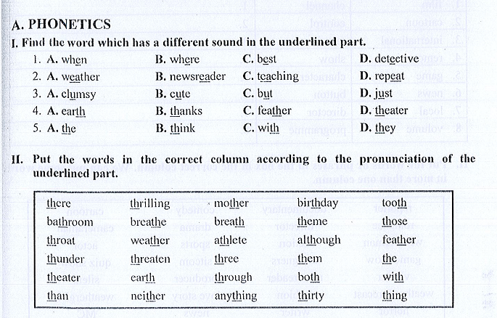
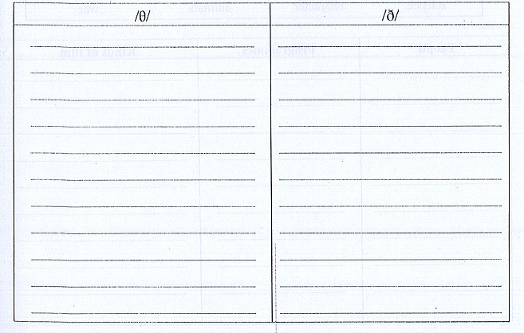
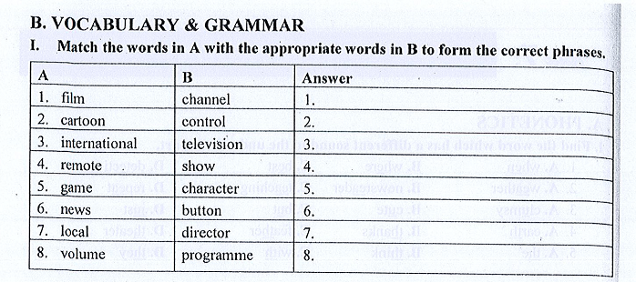
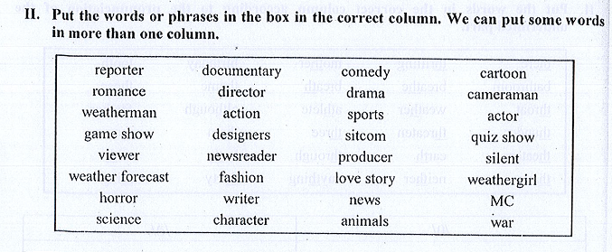
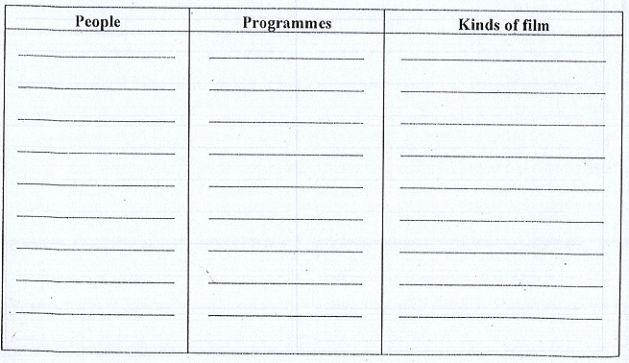
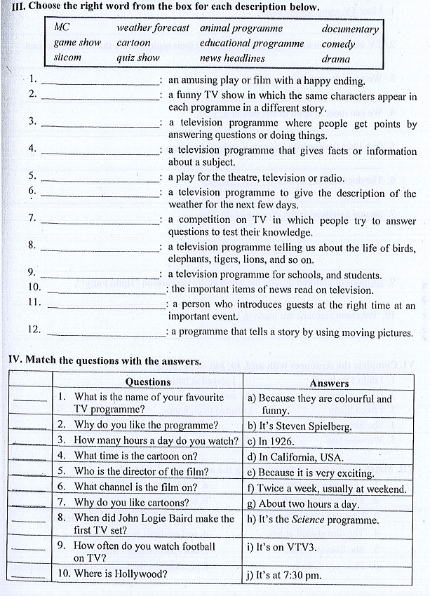
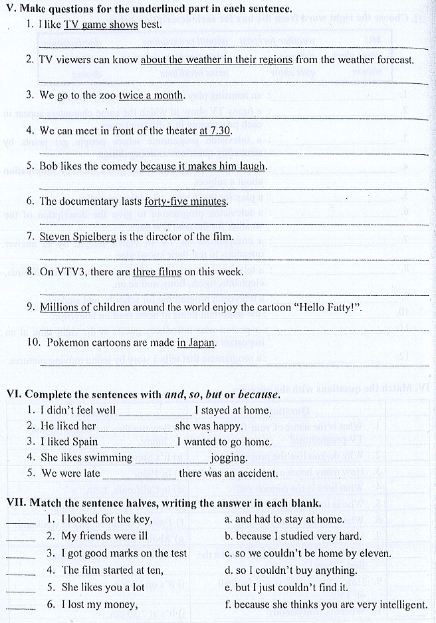

BÀI TẬP TOÁN 6
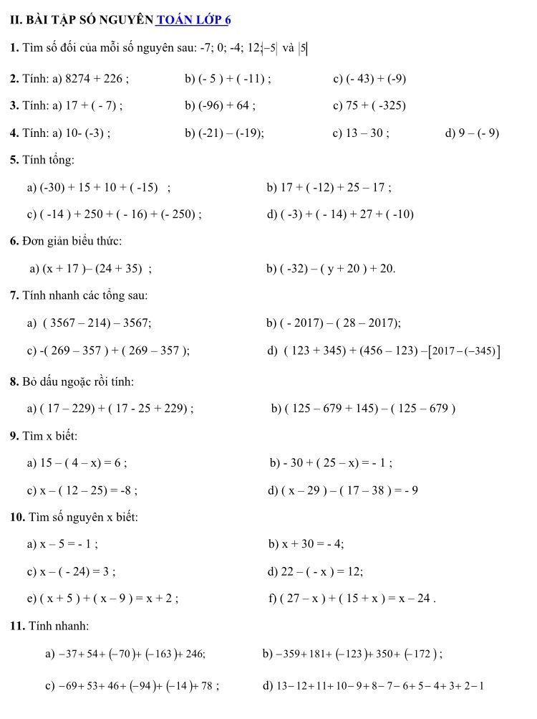
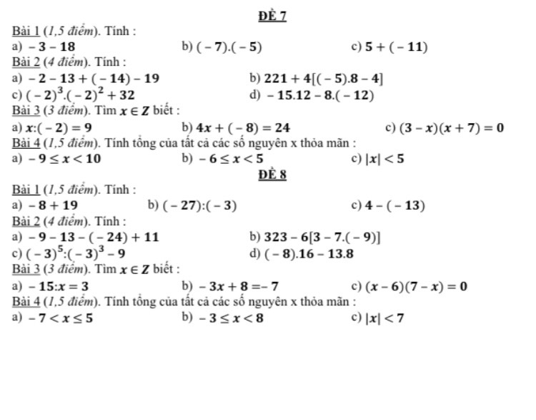
BÀI TẬP NGỮ VĂN 6
1. Tìm phép so sánh trong đoạn trích sau đây, nêu rõ tác dụng của phép so sánh đó :
“Dòng sông Năm Căn mênh mông, nước ầm ầm đổ ra biển ngày đêm như thác, cá nước bơi hàng đàn đen trũi nhô lên hụp xuống như người bơi ếch giữa những đầu sóng trắng. Thuyền xuôi giữa dòng con sông rộng hơn ngàn thước, trông hai bên bờ, rừng đước dựng lên cao ngất như hai dãy trường thành vô tận”.
(Đoàn Giỏi)
2. Trong câu ca dao :
Nhớ ai bổi hổi bồi hồi
Như đứng đống lửa như ngồi đống than.
a) Từ bổi hoi bồi hồi là từ láy có gì đặc biệt ?
b) Giải nghĩa từ láy bổi hổi bồi hồi.
c) Phân tích cái hay của câu ca dao do phép so sánh đem lại.
3. Trong bài Vượt thác có nhiều phép so sánh được thể hiện.
a) Em hãy xác định những phép so sánh đó.
b) Phép so sánh nào độc đáo nhất ? Vì sao ?
4. Em hãy viết một đoạn văn tả cảnh sông nước hay núi non, làng xóm ở quê em trong đó có sử dụng từ hai phép so sánh trở lên.

BÀI TẬP ÔN TẬP LÍ 6
I/ Khoanh tròn trước chữ cái của câu trả lời đúng
Câu 1. Câu nói nào đúng về ròng rọc cố định:
A. Chỉ có tác dụng đổi hướng lực kéo
B. Chỉ có tác dụng thay đổi độ lớn của lực kéo
C. Thay đổi cả hướng và độ lớn của lực kéo
D. Không làm thay đổi yếu tố nào của lực kéo
Câu 2. Khi kéo bao xi măng từ dưới lên tầng cao để sử dụng với lực kéo nhỏ hơn trọng lượng của vật thì người ta dùng:
A. mặt phẳng nghiêng. B. đòn bẩy. C. Ròng rọc động. D. Ròng rọc cố định.
Câu 3: Loại máy cơ đơn giản nào sau đây không cho lợi về lực?
A. Mặt phẳng nghiêng B. Ròng rọc động C. Ròng rọc cố định D. Đòn bẩy
Câu 4: Một chai dầu ăn có thể tích 0.001 m³ và khối lượng 800g. Khối lượng riêng của chai dầu ăn là:
A. 800 kg/m³ B. 80 kg/m³ C. 116.2 kg/m³ D. 1162 kg/m³
Câu 5: Để đo lực người ta dùng:
A. Cân B. Bình chia độ C. Thước kẻ D. Lực kế
Câu 6: Mặt phẳng càng nghiêng ít thì lực kéo trên mặt phẳng đó:
A. Càng nhỏ. B. Càng lớn
C. Không thay đổi D. Ít nhất bằng trọng lượng của vật
II. Tự luận :
Câu 1: Đổi đơn vị trong các câu sau đây:
a. 100g = ………….N b.25lít=…………….dm³
c. 356g =…………..kg d.200cm³=................m³

Câu 2: Chọn từ thích hợp để điền vào chỗ trống:
- Dụng cụ đo khối lượng là(1)……….
- Treo một vật nặng đứng yên trên một đầu sợi dây. Vật chịu tác dụng của hai (2)………….. Lực thứ nhất là(3)….................của quả nặng, lực thứ hai là(4)……………của sợi dây.
- Một vật có khối lượng là 2kg thì có trọng lượng ……………..
- Vật có khối lượng là 0,07 tấn thì có trọng lượng là:……………….
Câu 3 :Một lò xo có chiều dài tự nhiên là 28cm. Sau khi treo quả nặng vào thì chiều dài của lò xo lúc này là 32cm. Hãy tính độ biến dạng của lò xo khi treo quả nặng?
Câu 4: Nói “ Khối lượng riêng của chì là 11300 kg/m^{3”} , điều đó có ý nghĩa gì?

